10 Subject Line Strategies That Convert

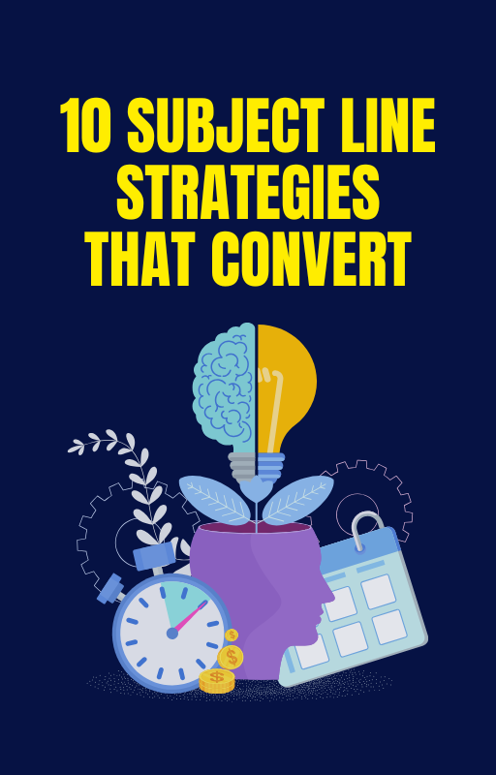


This is one of the most crucial areas in email marketing because the subject line is the first thing your audience sees. It's what makes them decide whether to open your email or move on. So, let’s get into the specifics of each strategy and show how you can optimize for maximum impact.
Personalization in Subject Lines Personalizing your subject lines is one of the most effective ways to grab attention and drive higher open rates. It’s no longer enough to just use their first name—let’s get creative!
Here’s how:
First Name: Including your subscriber's first name is a great starting point. A simple example could be: “Hey [First Name], Ready to Grab Your Special Deal?” This feels intimate and tailored, instantly making the reader feel seen.
Location-Based Personalization:
Use geographical data to make the email more relevant. For example, “Good Morning [First Name], Ready for a Big Sale in [City]?” Using location-based personalization taps into timing and can build an instant connection.
Past Interactions:
If you’ve tracked a previous purchase or interaction, use that data to personalize the subject line: “[First Name], Your Favorite [Product] is on Sale!” or “Time for a Refill on Your [Product Name], [First Name]?”
Behavioral Personalization:
Use behavior-triggered data, such as browsing history or previous purchases.
For example:
“[First Name], You Left Something in Your Cart!” or “Still Thinking About [Product]?”
Pro Tip: Personalization doesn’t just mean names. You can personalize content recommendations, timing, and even exclusive offers based on past actions. The more you know about your subscribers, the more you can tailor your subject lines to them.
Curiosity is one of the most powerful psychological triggers. When you create curiosity, you’re basically inviting the reader to click and satisfy their need to know what’s behind the door.
Use the Tease:
“You Won’t Believe What We’ve Got for You…” or “Can You Guess What’s on Sale This Week?” These kinds of subject lines suggest there’s something unexpected or exciting inside.
Ask Intriguing Questions:
People naturally want answers to questions. Example: “Are You Making These Mistakes With Your Marketing?” or “What’s Missing From Your Morning Routine?” By asking an engaging question, you’ll create a sense of urgency to find out more.
Keep It Vague:
Don’t give everything away. Let them wonder, but not for too long! “This One Thing Could Change Everything” or “Your Future Starts Today, Find Out How” creates that mix of mystery and intrigue.
Hint at a Solution:
Focus on offering a solution to a problem they have. For example, “Struggling to Sleep? Here’s the Secret to a Better Night’s Rest.” You’re piquing their curiosity by presenting a solution they didn’t know existed.
Pro Tip:
When using curiosity-driven subject lines, balance is key. If you’re too vague, it might seem like spam. If you’re too specific, you lose the element of surprise. Keep your teaser short and snappy, and always deliver what you promise inside the email.
Time-Sensitive and Urgency Tactics People hate to miss out. Urgency is a powerful motivator for getting people to take action quickly.
The key is creating limited-time offers or exclusive deals that push people to open your email and act before it’s too late. Limited Time Offers: “Last Chance! 24-Hour Flash Sale!” or “Only 3 Hours Left for 50% Off!” Emphasize the time crunch to prompt immediate action.
Scarcity:
“Hurry! Only 10 Items Left!” or “Almost Gone: Your [Product] is Running Out!” Using scarcity creates the perception that the product is highly desirable and in limited supply.
Countdowns:
Implement countdowns directly in your subject line, like “Hurry! 3 Days Left to Save 20%!” or “Only 24 Hours Until the Big Event!” This is an effective way to build anticipation and urgency around an offer.
Event-Based Deadlines:
Tie your urgency to a specific event or date, like “The Sale Ends Tonight” or “Only 2 Days Left to Get Your Black Friday Deal!” People love to act fast when the clock is ticking.
Pro Tip:
Don't just create urgency for sales—you can also use urgency for content. For example: “Read This Before It’s Gone!” or “Hurry, Only a Few Spots Left in Our Webinar”.
Use Numbers and Lists Subject lines with numbers and lists have been shown to increase open rates. People love numbers because they promise a quick, digestible experience. They’re more likely to open an email that seems organized and easy to consume.
Use Odd Numbers:
Research shows that odd numbers (e.g., “5 Tips”, “7 Secrets”) often outperform even numbers because they stand out as a bit more unique or unexpected.

Offer a Quick Fix:
Subject lines like “3 Quick Steps to Boost Your Sales” or “5 Ways to Simplify Your Morning Routine” promise readers a fast solution. They know exactly what they’re getting into and appreciate that it’s easy to digest.
How-To & Lists:
People love to learn things quickly. Try something like “10 Marketing Hacks You Need to Know” or “7 Ways to Make Your Product Stand Out”. This creates an expectation of actionable insights in a clear, organized manner.
Specific Numbers:
Don’t be afraid to get specific with numbers. For example, “Save 63% on Your Next Purchase!” or “Get 12 Free Templates Today!” Specific numbers build credibility and set clear expectations.
Pro Tip:
Keep your list-based subject lines short and focused. Too many numbers or items in a list can overwhelm the reader. Keep it to a digestible amount that teases just enough to make them want more.
Benefit-Driven Subject Lines Your audience wants to know what’s in it for them. By focusing on the benefits your email offers, you can create subject lines that resonate with their needs, desires, and pain points.
Solve a Problem
“Sick of Poor Sleep? Try This Simple Fix” or “Get Rid of Back Pain With These 5 Simple Tips”—highlighting a pain point followed by a solution immediately grabs attention.
Use Aspirational Language:
Tap into the aspirations of your audience. For example: “Unlock Your Best Year Yet” or “Achieve Your Dream Body in Just 30 Days!” People love subject lines that promise improvement and success.

Make it Tangible:
Be as specific as possible when communicating the benefit. “Boost Your Conversions by 30%” or “Get Your Dream Job in 6 Easy Steps”—this is more impactful than vague promises.
Be Specific About Results:
If you have statistics or real-life results to share, include them! “Over 2,000 Customers Are Loving Our New Feature!” or “How One Email Increased Our Sales by 40%”.
Pro Tip:
Avoid focusing solely on the product features. Instead, focus on how it improves the customer’s life. Benefits should feel relevant, compelling, and immediate!
Intriguing or Bold Statements An attention-grabbing, bold statement can cut through the noise and compel your subscribers to open the email. This works best when the subject line feels bold, unexpected, or controversial.
Surprise Them:
A statement like “You’re Doing It All Wrong—Here’s the Right Way!” or “Why Everything You Know About [Topic] Is Wrong” generates a sense of curiosity and rebellion.
Be Bold & Confident:
Confidence can draw attention. “This Will Be the Best Investment You’ll Ever Make” or “You Deserve This Luxury Experience”—these statements make bold promises and generate interest.
Shocking Statements:
When appropriate, use shocking subject lines that make people want to know why. “The Truth About [Topic] You Won’t Believe” or “The Secret No One Is Telling You About [Topic]”.

Be Playful or Humorous:
Bold doesn’t always have to be serious. A subject line like “Is This the Funniest Thing You’ll Read Today?” or “We Bet You Can’t Resist This Deal” adds humor and makes the email feel lighthearted.
Pro Tip:
If you use bold statements, ensure the content lives up to the subject line inside. Nothing kills trust faster than misleading promises!
Ask a Provocative Question Asking a thought-provoking question in the subject line invites readers to ponder their own situation and compels them to open the email to get the answer.
Tap Into Their Needs:
“Are You Ready for Your Dream Vacation?” or “What’s Holding You Back From Success?”—questions like this encourage self-reflection and curiosity.
Generate Emotion:
“Do You Want to Change Your Life?” or “What Would You Do With an Extra $1,000 a Month?” These types of questions tap into deep emotions and desire for change.
Challenge Their Thinking:
“Think You Know Everything About [Topic]? Think Again!” or “Why You’re Still Not Getting the Results You Want” challenges your audience to reconsider their beliefs.
Offer the Answer:
The key with a question subject line is that you should offer the answer or solution inside the email. You don’t want to leave them hanging.

Pro Tip:
Keep your questions short, specific, and aligned with the email’s content. Too many questions or a vague question will confuse readers.

